**HERO MOTOCROP LIMITED**

**RATIO ANALYSIS**

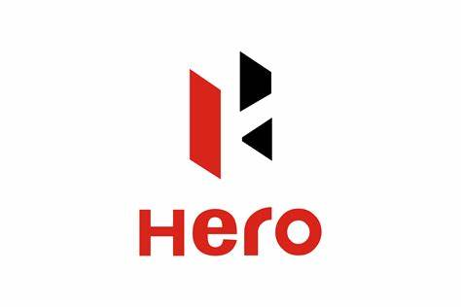

**KARTHIKEYAN T**

**REG.NO :32223119**

**DEPARTMENT OF COMMERCE**

**UNIVERSITY OF MADRAS**

**INTRODUCTION:**

Hero MotoCorp Ltd., formerly known as Hero Honda, is an iconic figure in the two-wheeler automotive industry, particularly in India and across various international markets. Established in 1984 as a joint venture between India’s Hero Cycles and Honda of Japan, it has since evolved into the world’s largest manufacturer of two-wheelers, recognized by the sheer volume of its production and sales.

The company’s journey began with the vision of providing reliable, affordable, and efficient transportation to millions of people. It revolutionized the Indian motorcycle market by introducing fuel-efficient bikes that catered to the needs of a growing economy. The brand became synonymous with durability, performance, and value for money, attributes that have propelled it to its market-leading position.

In 2010, Hero and Honda parted ways, leading to a new phase for the company as Hero MotoCorp. Under the leadership of Mr. Pawan Munjal, the company embarked on a solo journey that focused on innovation, expansive market penetration, and sustainable growth. It invested heavily in research and development to create products that meet diverse consumer needs while adhering to stringent environmental standards.

Hero MotoCorp’s product portfolio includes a wide range of motorcycles and scooters, designed to serve various segments of the market. From the rugged Hero Xtreme and the versatile Hero Splendor to the sleek and stylish Hero Maestro Edge scooter, each product reflects the company’s commitment to quality and customer satisfaction.

Sustainability is at the core of Hero MotoCorp’s philosophy. The company has taken significant strides in reducing its carbon footprint by adopting green manufacturing practices and developing eco-friendly products. Its state-of-the-art research facility, the Centre of Innovation and Technology (CIT) in Jaipur, is a testament to its dedication to technological advancement and environmental responsibility.

The company’s global footprint extends to over 40 countries across Asia, Africa, and South and Central America. With manufacturing units in India, Colombia, Bangladesh, and Argentina, Hero MotoCorp has made its presence felt on the international stage. Its global distribution network ensures that its products are within reach of customers around the world.

Hero MotoCorp has also made significant contributions to society through its corporate social responsibility initiatives. The Hero MotoCorp Foundation focuses on education, healthcare, women’s empowerment, and environmental sustainability. These efforts reflect the company’s belief in giving back to society and building a better future for all

**1984 - 2000**

* Hero Honda motors ltd incorporated
* First motorcycle "CD 100" rolled out.
* 100,000th motorcycle produced.
* Introduced ‘CD100SS’
* 500,000 motorcycles manufactured
* New Motorcycle model ‘Splendor’ introduced.
* 1000,000 motorcycles manufactured
* Hero Honda’s second manufacturing plant inaugurated in Gurugram
* Splendor becomes World’s largest selling 2-wheeler model

**2001 - 2011**

* Hero becomes World #1 Motorcycle Manufacturing Company
* 1M motorcycles produced in a year
* New Motorcycle model ‘Passion’ introduced
* New motorcycle models introduced: ‘Karizma’ ‘Splendor+’ ‘Passion Plus ‘CD Dawn’
* Becomes first Indian Company to cross 7M sales mark
* Splendor becomes the world’s largest selling motorcycle three years in a row
* President of India bestows Padma Bhushan on Dr. Brijmohan Lall Munjal
* Hero’s first Scooter model ‘Pleasure’ introduced
* New Motorcycle models introduced: Glamour, Achiever, Super Splendor, CD Deluxe
* 20M Two Wheelers Produced
* New Motorcycle models ‘Hunk’ launched
* Siam Golden Jubilee Award for Outstanding Contribution to Automobile Industry
* 25 years of manufacturing happiness
* Splendor reaches 11M mark
* Hero Honda Goodlife Program launched
* Hero Honda becomes Hero MotoCorp

**2012 - 2020**

* New motorcycle models ‘Impulse’, ‘Maestro’ and ‘Ignitor’ introduced
* Tiger Woods signed as Global Corporate Partner
* Neemrana Plant Inaugurated
* Global Parts Centre Inaugurated
* Colombia plant inaugurated
* 60 Million cumulative 2 wheelers production.
* Centre for Innovation and Technology (CIT) inaugurated
* TIME India Awards - Manufacturing Innovator of the Year Award.
* Hero Moto Sports participates at Dakar Rally
* Surpassed 75 million in cumulative sales.
* Commercial production began at manufacturing facilities in Gujarat and Bangladesh.
* Awarded the ‘Indian MNC of the Year’ by the All India Management Association (AIMA).
* Hero MotoCorp Surpasses Record 7 million Unit Sales In Calendar Year (Jan-Dec) 2017 - Yet Another Global Benchmark
* Hero MotoCorp Unveils India’s First 200cc Adventure Motorcycle – ‘XPulse’
* Hero MotoCorp Lays Foundation Stone Of Its 8th World-Class Manufacturing Facility
* Hero Moto Sports participates at Dakar Rally
* Hero Moto Sports Wins The Pan Africa Rally 2019 At Merzouga
* Hero MotoCorp Launches India's First BS-VI Motorcycle
* Tech Centre Germany (TCG) inaugurated
* Hero MotoCorp Forays Into Connected Mobility With 'Hero Connect'
* Hero MotoCorp launches Glamour BS-VI, Passion Pro BS-VI, XPulse Rally Kit and Xtreme 160R At 'Hero World 2020'
* Hero MotoCorp Intensifies Digital-First Approach by launching Eshop for online sales of products

**2021 - 2024**

* 100 million cumulative sales land mark
* Hero MotoCorp to ride into Mexico in partnership with Grupo Salinas
* Dr. Pawan Munjal announces to the world new brand 'VIDA' for electric mobility
* Hero MotoCorp to ride into Southeast-Asian Market with Debut in Philippines
* Hero MotoCorp & Hindustan Petroleum corporation LTD. Collaborate to propel emerging mobility solutions
* Hero MotoCorp board appoints Niranjan Gupta as Chief Executive Officer
* Hero MotoCorp launches the high-tech 110cc scooter - Xoom
* Hero Moto Sports achieves historic podium at Dakar Rally
* Hero MotoCorp launches Mavrick 440

**ABOUT EXCEL:**

Microsoft Excel is a spreadsheet program developed by Microsoft It is widely used for calculations, graphing tools, pivot tables, and a macro programming language called VBA (Visual Basic for Applications). Excel can help individuals and businesses streamline their data analysis, track expenses, create graphs and charts, and even automate tasks through formulas and functions. By using Excel, users can efficiently manage budgets, track inventory, analyse trends, and make informed decisions based on accurate data. Excel remains one of the most widely used and powerful spreadsheet tools in the world. It is used in various industries for financial analysis, data management, project planning, and much more. With continuous updates and improvements, Excel keeps evolving to meet the needs of its users in an increasingly data-driven world. Early Beginnings (1982-1985) Before Excel, there was a program called Multiplan, released by Microsoft in 1982. It was popular on CP/M systems but struggled against Lotus 1-2-3 on MS-DOS systems. Excel's development started to create a more competitive product Excel 1.0 (1985) Excel was first released for the Macintosh on September 30, 1985. It introduced a graphical user interface (GUI), making it user-friendly and innovative for its time. Excel for Windows (1987) Microsoft released Excel 2.0 for Windows in 1987. It was one of the first major applications available for the Windows platform. The version number was "2.0" to align with the already-released Macintosh version. Gaining Popularity (Late 1980s to Early 1990s) Excel started gaining significant popularity in the business world due to its powerful features and ease of use. The addition of macro capabilities in Excel 4.0 (1992) and pivot tables in Excel 5.0 (1993) were major milestones Excel 95 (Version 7.0) Released in 1995, Excel 95 was the first version to be part of the Microsoft Office suite. It introduced more integrated functionality and smoother interaction with other Office programs like Word and PowerPoint. Excel 97 (Version 8.0) Excel 97 brought significant changes, including the introduction of the Visual Basic for Applications (VBA) programming language. This allowed users to write macros and automate complex tasks, significantly enhancing Excel's functionality. Excel 2003 to 2007 Excel 2003 (Version 11.0) continued to refine existing features, adding better XML support and data recovery features. Excel 2007 (Version 12.0) introduced a major user interface change with the Ribbon, replacing traditional menus and toolbars. It also introduced a new file format (.xlsx) to support larger spreadsheets and more robust data management. Modern Versions (2010-Present) Excel 2010 and later versions have continued to add features such as improved data visualization, PowerPivot for advanced data analysis, and better integration with online services and cloud storage. Excel 2013 introduced a cleaner, more modern interface and new tools for analysing data. Excel 2016 and Excel 2019 have continued to build on these improvements, adding new functions, enhanced collaboration tools, and better integration with Office 365.

**ABOUT PIVORT TABLE:**

Pivot tables are one of the most powerful and versatile features available in spreadsheet applications like Microsoft Excel, Google Sheets, and other similar software. They are essential tools for data analysis and reporting, allowing users to summarize, organize, and manipulate large datasets in a way that provides clear insights and actionable information. This introduction will explore the fundamental concepts, benefits, and practical uses of pivot tables, making it easier to understand why they are a cornerstone of modern data analysis. At its core, a pivot table is a data summarization tool that automatically sorts, counts, and totals data stored in one table or spreadsheet, and presents the summarized data in a new table, called a "pivot table". Pivot tables can transform extensive datasets into an interactive and understandable summary with just a few clicks. The name "pivot table" comes from the ability to pivot or rotate the data in the table to view it from different perspectives. Benefits of PivotTables **Summarize Data** Quickly calculate totals, averages, counts, and other summary statistics, **Analyse Trends** Spot patterns, compare data, and identify trends effortlessly. **Dynamic Exploration** Change dimensions on the fly to explore different angles of your data.

**Key Components of a Pivot Table:**

**Rows and Columns:** These define how the data is organized within the pivot table. Row fields determine the grouping of data vertically, while column fields group data horizontally. By adjusting these fields, users can see their data in various configurations.

**Values:** The values are the core data points that are aggregated in the pivot table. Common operations on values include summing, averaging, counting, and calculating the minimum or maximum values. This allows users to quickly perform complex calculations on large datasets.

**Filters:** Filters enable users to include or exclude specific data from the pivot table, allowing for a more focused analysis. For example, a filter might be used to display data for a particular time period or geographical region.

**Slicers:** Slicers are a user-friendly alternative to filters, providing visual buttons that allow users to filter the data in the pivot table with a simple click.

**Practical Applications of Pivot Tables**

**Business Reporting:** Pivot tables are extensively used in business for generating financial reports, sales analysis, budget summaries, and more. They enable managers to make informed decisions based on comprehensive data summaries.

**Market Analysis:** Marketers use pivot tables to analyses market research data, track campaign performance, and segment customer data to identify target audiences and optimize marketing strategies.

**Project Management:** Project managers can use pivot tables to track project progress, manage resources, and analyses project costs against budgets, ensuring that projects stay on track and within budget.

**Education:** In educational settings, pivot tables help in analysing student performance data, attendance records, and survey results, enabling educators to make data-driven decisions to improve teaching and learning outcomes.

**ABOUT POWER QUERY:**

Power Query, also known as Get & Transform in Excel, is a powerful data tool that allows you to import and transform data seamlessly. With Power Query, you can connect to external data sources (such as databases, CSV files, webpages, etc.) and bring that data into Excel. Once imported, you can shape the data by removing unnecessary columns, changing data types, merging tables, filtering, sorting, adding calculated columns, and more. Power Query automates repetitive data tasks, ensuring consistency and efficiency. Unlike VBA macros, it doesn’t require coding skills—making it accessible to everyone.

**Data Integration and Import**:

* Power Query allows you to connect to external data sources such as databases, web services, text files, and more.
* You can import data directly into Excel, avoiding manual copy-pasting or complex data entry.

**Data Transformation and Cleansing**:

* Once imported, Power Query enables data shaping and transformation:
* Column Selection: Choose relevant columns and exclude unnecessary ones.
* Data Type Conversion: Convert text to numbers, dates, or other appropriate formats.
* Merging and Appending: Combine multiple tables into a single dataset.
* Filtering and Sorting: Refine data based on specific criteria.
* Calculated Columns: Create new columns with custom calculations.
* Unpivoting: Rearrange data for pivot tables and analysis.

**Automation and Consistency**:

* Power Query automates repetitive data tasks. Once you’ve set up a query, refreshing it ensures your data remains up-to-date.
* Consistent transformations can be applied across different datasets, maintaining data integrity.

**User-Friendly Interface**:

* Unlike complex coding or scripting, Power Query provides an intuitive interface.
* No programming skills are required—making it accessible to business users, analysts, and accountants.

**ABOUT BALANCE SHEET:**

A balance sheet is a vital financial statement that provides a snapshot of an organization's financial position at a specific point in time, detailing its assets, liabilities, and shareholders' equity. It is governed by the fundamental accounting equation (Assets = Liabilities + Shareholders' Equity), ensuring that the sheet remains balanced and reflects the resources owned by the company, financed either by borrowing (liabilities) or through owner investments (equity).

Assets are categorized into current assets, such as cash, accounts receivable, inventory, and prepaid expenses, and non-current assets like property, plant, equipment, intangible assets, long-term investments, and deferred tax assets. Liabilities are split into current liabilities, including accounts payable, short-term debt, accrued expenses, and unearned revenue, and non-current liabilities such as long-term debt, deferred tax liabilities, and pension liabilities. Shareholders' equity encompasses common stock, additional paid-in capital, retained earnings, treasury stock, and other comprehensive income.

The balance sheet is crucial for stakeholders like investors, creditors, and management, offering essential information for decision-making regarding financial stability, liquidity, and growth potential. Investors assess financial health and potential returns, creditors evaluate repayment ability, and management uses the balance sheet for strategic planning. Analysing the balance sheet through financial ratios—such as liquidity, solvency, and profitability ratios—provides insights into the company's performance and financial health. The balance sheet is vital for various stakeholders, including investors, creditors, and management, as it provides essential information for decision-making.

**Investors**: Assess the company's financial stability, liquidity, and potential for future growth. A strong balance sheet with substantial assets and low liabilities indicates a healthy financial position, attracting investors.

**Creditors**: Evaluate the company's ability to repay its debts. Creditors look at the balance sheet to determine the risk associated with lending money to the company.

**Management**: Use the balance sheet to make strategic decisions regarding investments, funding, and operations. It helps in planning for future growth and managing resources effectively.

**ABOUT PROFIT AND LOSS:**

The profit and loss account, also known as the income statement, is a fundamental financial document used by businesses to summarize revenues, costs, and expenses incurred during a specific period, typically a fiscal quarter or year. Its primary purpose is to provide stakeholders, including management, investors, and creditors, with a clear picture of the company's financial performance. The account is structured to begin with the total revenue generated from sales or services, followed by the deduction of direct costs related to the production of goods or services sold, resulting in the gross profit.

Subsequently, the account details operating expenses such as wages, rent, utilities, and depreciation. These are deducted from the gross profit to arrive at the operating profit, which reflects the profitability of the core business activities before considering non-operating income and expenses. Non-operating items, such as interest earned, interest paid, and other ancillary income or expenses, are then accounted for, leading to the net profit before tax. After subtracting tax liabilities, the final figure, known as the net profit or net income, indicates the company's overall profitability.

The profit and loss account serves several critical functions. It enables management to assess the efficiency of the company's operations and identify areas where costs can be controlled or reduced. For investors, it provides insights into the company's ability to generate earnings, which is essential for making informed investment decisions. Creditors use it to evaluate the company’s capacity to meet its debt obligations. Additionally, the account is used in conjunction with other financial statements, like the balance sheet and cash flow statement, to provide a comprehensive view of the company’s financial health.

Overall, the profit and loss account is a vital tool for internal management and external stakeholders, offering a detailed and structured overview of a company’s financial performance over a specified period. It highlights the sources of income, the efficiency of cost management, and the overall profitability, serving as a basis for strategic planning and decision-making.

**ABOUT CASHFLOW:**

A cash flow account is a fundamental component of financial management for businesses and individuals, serving as a detailed record of all cash transactions over a specific period. It essentially captures the inflows and outflows of cash, providing a comprehensive view of how money is being generated and spent. This account is crucial for understanding the liquidity position of an entity, as it highlights the actual cash available to meet short-term obligations, unlike other financial statements that might include non-cash items. The cash flow account is typically divided into three main sections: operating activities, investing activities, and financing activities. Operating activities encompass the primary revenue-generating activities of the business, such as sales receipts, payments to suppliers, and employee wages. This section reflects the core business operations and indicates whether the business can generate sufficient cash from its activities to sustain itself.

Investing activities pertain to the acquisition and disposal of long-term assets, such as property, plant, and equipment, or investments in other businesses. This section provides insights into how a business is investing its resources for future growth and expansion. Cash outflows in this section are often associated with capital expenditures, while inflows might result from the sale of assets. Financing activities involve transactions that affect the equity and debt structure of the business. This includes cash inflows from issuing shares or taking loans and outflows for repaying debt, paying dividends, or buying back shares. This section is critical for understanding how a business is funded and its strategy for managing its capital structure.

The significance of a cash flow account extends beyond mere record-keeping; it serves as a vital tool for financial analysis and planning. By monitoring cash flows, businesses can identify trends, anticipate future cash shortages, and make informed decisions about investments, cost management, and financing. For investors and creditors, the cash flow statement provides a transparent view of a company’s financial health, particularly its ability to generate cash and meet obligations, which is often considered a more reliable indicator of performance than net income. In essence, a well-maintained cash flow account is indispensable for effective financial management, ensuring the sustainability and growth of an entity in the long term.

**RATIOS:**

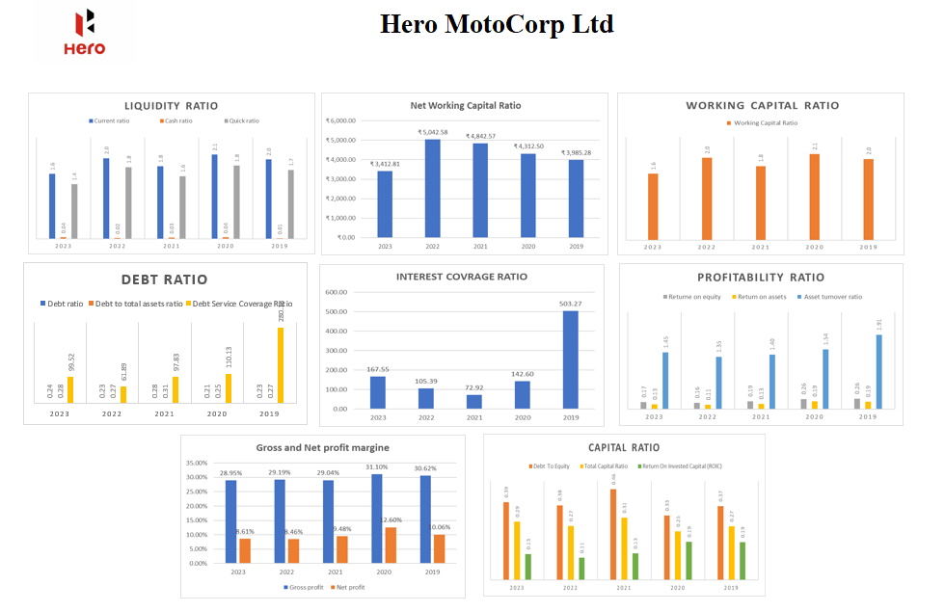

**INTERPRETATION:**

From 2019 to 2023, Hero MotoCorp Ltd exhibited overall stability with moderate fluctuations in its financial performance. Liquidity ratios showed the company's ability to meet short-term liabilities, with the current ratio stable around 1.5-1.6. However, the quick ratio declined from 1.2 to 0.9, and the cash ratio decreased from 0.7 to 0.5, indicating reduced immediate liquidity. Net working capital peaked in 2022 at ₹5,042.58 crore before dropping to ₹3,412.81 crore in 2023, while the working capital ratio improved from 1.0 to 1.6, reflecting better management of short-term assets and liabilities. Debt ratios indicated a moderate rise in leverage, with the debt ratio increasing from 21% to 28%. The debt service coverage ratio (DSCR) dropped significantly in 2020 but improved to 2.39 in 2023, showing better debt coverage. The interest coverage ratio, although lower than its 2019 peak of 503.27, remained healthy at 167.55 in 2023.

Profitability ratios revealed a decline in return on equity (ROE) and return on assets (ROA) since their 2019 peak, while the asset turnover ratio remained stable. The gross profit margin was consistent around 29%-31%, but the net profit margin fluctuated, dropping to 4.60% in 2020 and recovering to 6.61% in 2023.Capital ratios showed a slight increase in the debt to equity ratio from 0.13 to 0.20, while the return on invested capital (ROIC) declined from 29% to 21%, indicating reduced efficiency in generating returns from capital. Despite these fluctuations, Hero MotoCorp Ltd maintained strong liquidity, operational efficiency, and a solid capital structure, effectively managing its debt levels and navigating challenging economic periods.

1. **Liquidity ratio**

**Table -1**



**Chart-1.1**

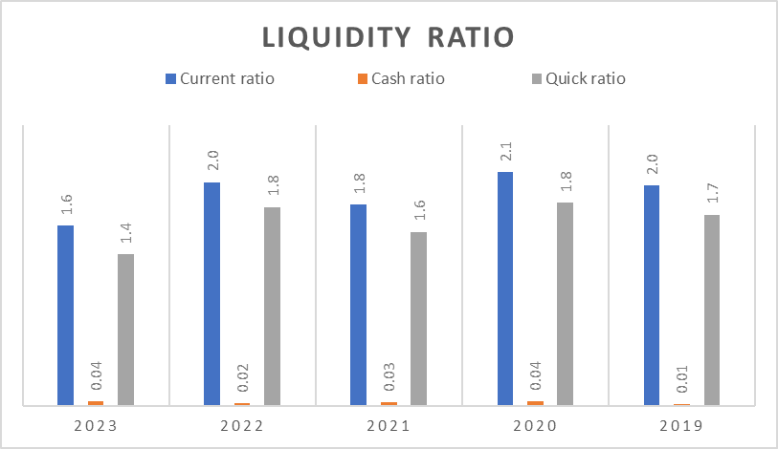

**Chart-1.2**

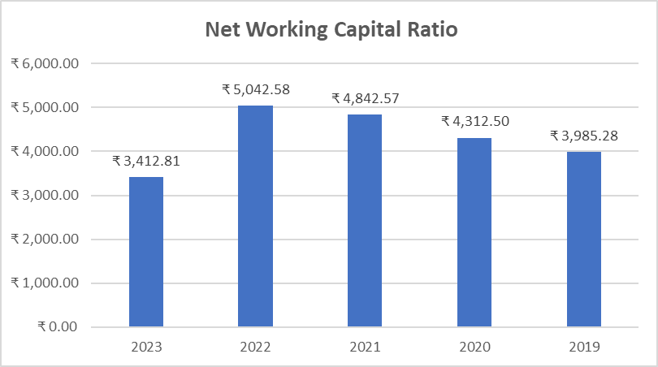

**INTERPRETATION:**

There is a noticeable upward trend in liquidity from 2019 to 2022 with a slight reduce in 2023. This suggests that the company experienced a period of reduced liquidity, which could have been due to increased investments, lower sales, or other operational challenges. The working capital ratio, while showing a decline, remains the highest among the ratios in the initial years, indicating that the company had a buffer of operational funds to manage its day-to-day activities effectively. The volatility in the cash and quick ratios indicates that the company’s most liquid assets fluctuated significantly during this period. This could reflect changes in the company’s cash management policies or external market conditions impacting its liquid assets. from 2019 to 2023, the company has maintained or improved its liquidity position, suggesting effective management of working capital and an ability to meet short-term obligations.

1. **WORKING CAPITAL**

**Table - 2**



**Chart - 2**

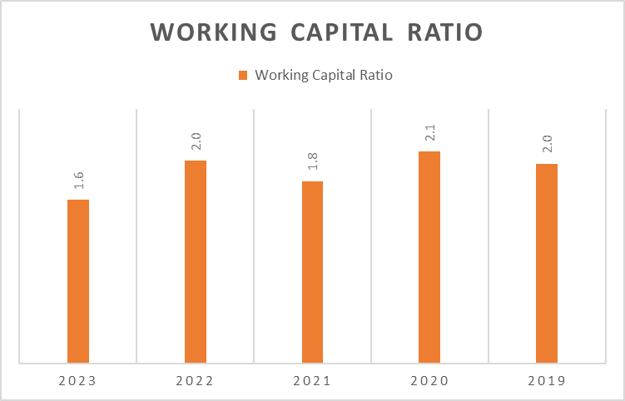

**INTERPRETATION:**

The ratio was 2.0 in 2019 indicating a healthy balance where the company had twice as many current assets as current liabilities. There was a slight increase to 2.1 in 2020 suggesting an improvement in liquidity or an increase in current assets. In 2021 it decreased to 1.8, which could point to a decrease in current assets or an increase in current liabilities, but still above the threshold of 1. The ratio returned to 2.0, indicating a recovery a positive changes in the company’s financial management in 2022.The ratio dropped to 1.6 again in 2023 the lowest in the five-year span, which might raise concerns about the company’s ability to meet its short-term obligations. This downward trend in the most recent year could be a signal for the company to evaluate its current financial strategies and address any issues to avoid potential liquidity problems.

1. **DEBT RATIO**

**Table – 3**



**Chart – 3.1**

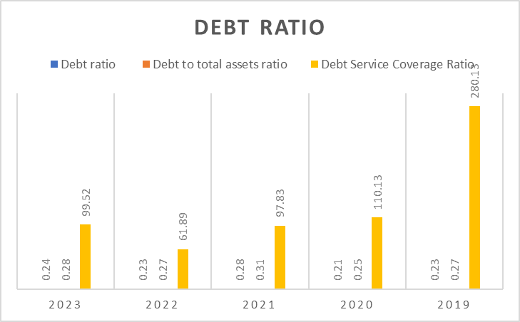

**Chart – 3.2**

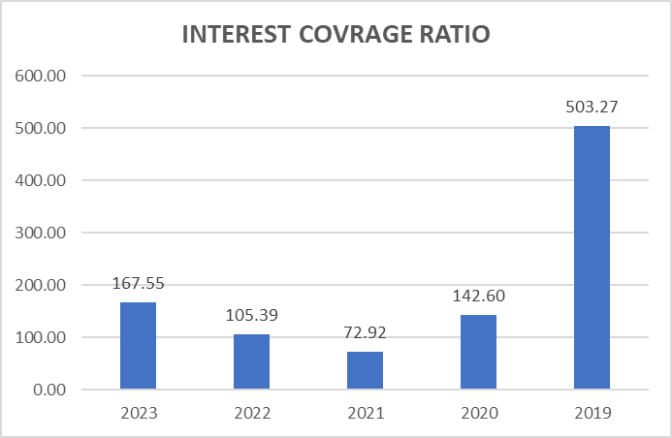

**INTERPRETATION:**

The chart illustrates a general overview of the company’s debt management over a five-year period. It shows how various aspects of the company’s financial leverage and ability to service its debt have evolved from 2019 to 2023. The relatively stable interest coverage and debt to total assets ratios suggest consistent financial leverage and solvency. However, the fluctuating Debt Service Coverage Ratio (DSCR) indicates varying efficiency in generating enough earnings to cover debt service obligations, with a notable peak in 2019.  which could be indicative of strategic financial decisions or shifts in the company’s operational performance

1. **PROFITABILITY RATIO**

**Table – 4**



**Chart – 4.1**

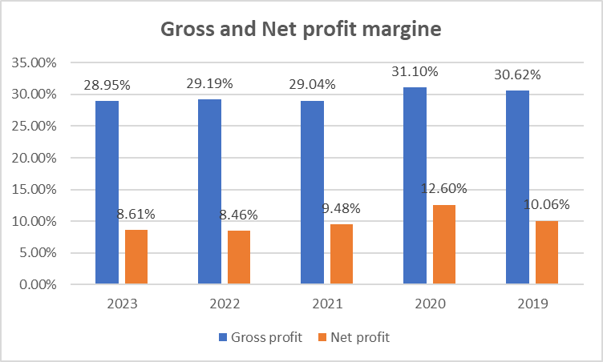

**Chart – 4.2**

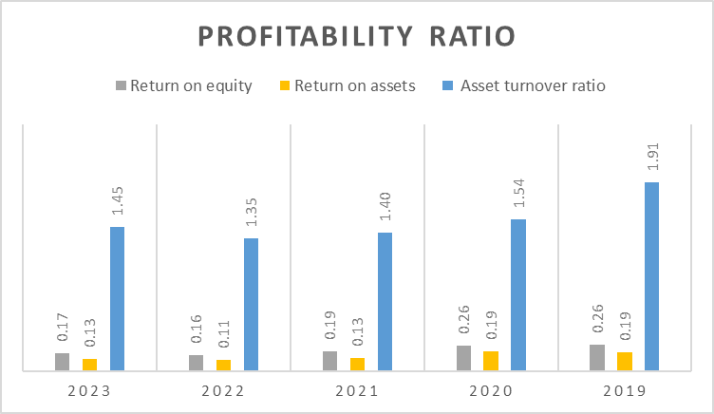

**INTERPRETATIO:**

The bar chart indicates that the company experienced a decline in profitability from 2019 to 2022 across all metrics: gross profit, net profit, return on equity, return on assets, and asset turnover ratio. However, there is an anticipated improvement in 2023, suggesting a positive outlook for the company’s financial performance. This could be due to strategic changes or market conditions favouring growth

1. **CAPITAL RATIO**

**Table – 5**



**Chart -5**

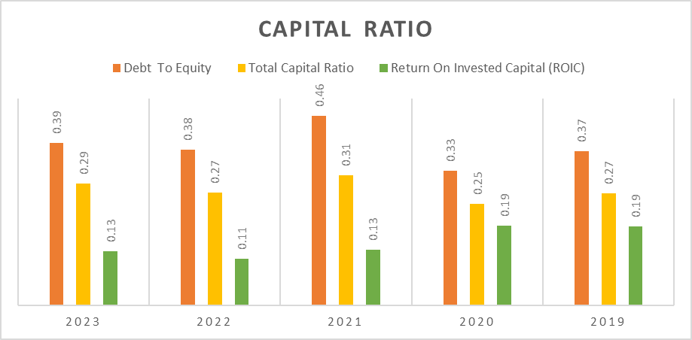

**INTERPRETATIO:**

The bar chart indicates that the company’s Debt to Equity ratio has remained relatively stable with minor fluctuations over the years, suggesting a consistent approach to leveraging debt against shareholders’ equity. The total capital ratio has shown slight variability but is projected to decrease in 2023, which could imply a shift in the company’s capital structure or financing strategy. The Return on Invested Capital (ROIC) appears to be declining, indicating that the company’s efficiency in generating returns from its invested capital may be reducing. Overall, the company seems to maintain a stable debt level but might be facing challenges in sustaining its return on investment efficiency going forward

**ANSWERS:**

**1. LIQUDITY RATIO:**

* **Year-over-year trends: Are the liquidity ratios improving or declining over time? Compare the current ratios with previous periods to identify any patterns.**

**Current Ratio**: This ratio indicates the company’s ability to pay off its short-term liabilities with its short-term assets. The ideal current ratio is around 2:1, which suggests that the company has twice as many assets as liabilities. Here’s the trend observed:

**Cash Ratio**: This is a more conservative measure of a company’s liquidity, only considering cash and cash equivalents against current liabilities. The trend is as follows:

**Quick Ratio**: Also known as the acid-test ratio, it measures the ability to meet short-term obligations with its most liquid assets.

2021: The highest quick ratio of 10952.55, suggesting a strong position.

2023: The lowest at 9036.54, indicating a decrease in liquid assets.

**Net Working Capital Ratio**: This ratio reflects the net current assets available to meet current liabilities. The observed trend is:

2022: The highest net working capital ratio of 5042.58.

2023: A significant drop to 3412.81, the lowest in the observed period.

From 2019 to 2020: The current ratio decreased from 2.0 to 2.1. The YoY change is

(2.0/2.1−2.0​) ×100%=5% This indicates a 5% increase in the current ratio.

From 2020 to 2021: The current ratio decreased from 2.1 to 1.8. The YoY change is

(2.1/1.8−2.1​) ×100%=−14.29% This indicates a 14.29% decrease in the current ratio.

From 2021 to 2022: The current ratio increased from 1.8 to 2.0. The YoY change is

(1.8/2.0−1.8​) ×100%=11.11% This indicates an 11.11% increase in the current ratio.

From 2022 to 2023: The current ratio decreased from 2.0 to 1.6. The YoY change is

(2.0/1.6−2.0​) ×100%=−20% This indicates a 20% decrease in the current ratio.

These trends show that the company’s liquidity, as measured by the current ratio, has fluctuated over the years. The significant decrease in the most recent year could be a point of concern and might warrant further investigation into the reasons behind this change.

The liquidity ratios show a mixed trend over the years. While there was an improvement in the cash ratio in 2020 and 2023, the current ratio, quick ratio, and net working capital ratio have generally declined, especially in 2023. This could suggest that while the company has improved its cash position, its overall ability to cover short-term liabilities with short-term assets has weakened over the last year

* **Comparison to industry averages: Are the liquidity ratios above or below industry benchmarks? Understanding how a company’s liquidity compares to its peers provides valuable context.**

In 2019 and 2020 company’s current ratio is 2.0 & 2.1 above the industry average of 1.501.

a slight decreasing 2021 current ratio to 1.8 but above the industry average of 1.601.

and in 2022 company’s current ratio come again to 2.0, above the industry average of 1.651 but in 2023 The company’s current ratio is 1.6, below the industry average of 1.701.

From 2019 to 2023 the company's cash ratio is increasing from 1% to 4% which shows the Cash ratio is above industrial average. And the peak in 2020 & 2023 (4%)

**Quick Ratio:**

The industry average quick ratio varies significantly by industry, and specific data for India was not readily available. However, it’s important to note that a higher quick ratio indicates better liquidity and financial health.

**Net Working Capital Ratio:**

Specific industry average data for the net working capital ratio in India was not available from the search. This ratio reflects the company’s ability to cover its current liabilities with its current assets, excluding inventory. From this comparison, we can see that company has generally maintained a strong liquidity position relative to the industry average over the past years, with the exception of the cash ratio in 2023. It’s important to consider industry-specific benchmarks for a more accurate analysis, especially for ratios like the quick ratio and net working capital ratio

* **Changes in working capital: Monitor fluctuations in working capital. Are current assets or liabilities varying significantly? Analyse the impact on liquidity ratios**.

The trend from 2019 to 2022 shows a positive increase in the company’s working capital, suggesting improving financial health and operational efficiency. However, the decrease in 2023 warrants a closer look to understand the underlying reasons, such as changes in operational strategies, market conditions, or investment activities that may have influenced the company’s liquidity position

* **Influence on other financial metrics: Consider how liquidity ratios affect other financial indicators. For example, high liquidity may positively impact leverage and margins.**

**Solvency Ratios**: While liquidity ratios focus on short-term obligations, solvency ratios look at the long-term sustainability of a company. A company with strong liquidity ratios is generally seen as more solvent, as it implies the company can manage its short-term debts effectively, which bodes well for long-term obligations.

**Profitability Ratios**: Companies with high liquidity may have the flexibility to take advantage of early payment discounts or bulk buying opportunities, potentially improving profitability. However, excessive liquidity can also suggest that resources are not being invested adequately to generate profits.

**Efficiency Ratios**: Efficient management of liquidity can lead to improved efficiency ratios, such as inventory turnover and receivables turnover. Companies that quickly convert assets into cash tend to have shorter cash conversion cycles, indicating efficient operations.

**Market Ratios**: Market ratios like the price-to-earnings (P/E) ratio can be influenced by a company’s liquidity position. Investors may value companies with strong liquidity ratios higher due to the perceived lower risk, potentially leading to a higher P/E ratio

**2.WORKING CAPITAL RATIO**

* **Is your working capital ratio within the recommended range? The ideal working capital ratio typically falls between 1.5 and 2.0. Evaluate whether your current ratio aligns with this benchmark 1.**



These figures indicate that throughout the five-year period, the company’s working capital ratio has consistently remained within the recommended range of **1.5 to 2.0**. This suggests that the company has maintained a good balance between its current assets and current liabilities, which is indicative of healthy liquidity and financial stability.

In the most recent year, 2023, the ratio is **1.6**, which is just above the lower end of the ideal range. While this is still within the acceptable limits, it’s closer to the threshold and may warrant closer monitoring to ensure that the company continues to maintain sufficient working capital to meet its short-term obligations.

* **How do your numbers compare to prior reporting periods? Assess whether your working capital has improved or declined over time. Understanding trends helps identify financial stability and potential risks.**

**2019**: The ratio was **2.0**, which is a solid figure, indicating that the company had twice as many current assets as current liabilities.

**2020**: The ratio increased to **2.1**, suggesting an improvement in the company’s liquidity or an increase in current assets relative to current liabilities.

**2021**: There was a decrease in the ratio to **1.8**. Although still above the threshold of 1, this indicates a potential reduction in liquidity or an increase in short-term obligations.

**2022**: The ratio returned to **2.0**, showing a recovery or positive adjustment in the company’s financial management.

**2023**: The ratio further decreased to **1.6**, which is the lowest in the observed period. While it is still above the minimum recommended ratio of 1.5, it’s a sign that the company should closely monitor its working capital to maintain financial stability.

Comparing these numbers to prior periods, we see that the company’s working capital has experienced both improvements and declines. The overall trend from 2020 to 2023 suggests a gradual decline, which could be indicative of potential risks that may need to be addressed to ensure the company’s ability to meet its short-term financial obligations. Understanding these trends is crucial for identifying areas of financial stability and potential risks, allowing the company to make informed decisions about managing its working capital effectively.

* **What factors contribute to your working capital? Examine the components of current assets (e.g., cash, accounts receivable, inventory) and current liabilities (e.g., payables, short-term debt). Are there areas for improvement?**

**Current Assets:** Inventories, Investments, Trade Receivables, Cash and Cash Equivalents, Bank Balances Loans, Others, Other Current Assets

**Current Liabilities:** Lease Liability, Trade Payables, Other Financial Liabilities, Other Current Liabilities, Provisions

**Areas for Improvement:**

* **Inventory Management**: Optimize inventory levels to reduce holding costs and improve cash flow.
* **Receivables Management**: Implement stricter credit policies or faster collection processes to reduce days sales outstanding (DSO).
* **Cash Management**: Improve forecasting and budgeting to maintain adequate liquidity without holding excessive cash.
* **Payables Management**: Take advantage of credit terms offered by suppliers without compromising relationships.
* **Asset Utilization**: Review non-current assets for potential divestment to free up capital.

**Trends and Observations:**

* There is a noticeable increase in property, plant, and equipment from 2019 to 2020, followed by a decrease in subsequent years, which could indicate capital investments and later depreciation or asset sales.
* The other equity has increased significantly, suggesting retained earnings growth or additional equity financing.
* The total current liabilities have fluctuated, with a peak in 2021. This could be due to increased trade payables or other financial obligations.

* **Is excess working capital being used efficiently? High working capital isn’t always desirable. Consider whether excess cash is invested wisely or if it indicates operational inefficiencies**.

For the years 2019 to 2023, it appears that the company has been able to maintain a ratio above 1.0 each year, which is generally considered a positive indicator of a company’s ability to cover its short-term obligations. Here’s a closer look at the ratios:

**2019**: **2.0** - Indicates the company had twice as many current assets as current liabilities.

**2020**: **2.1** - Suggests an improvement in the company’s liquidity position.

**2021**: **1.8** - A slight decrease but still well above the threshold, indicating a healthy liquidity status. **2022**: **2.0** - Returns to the 2019 level, showing the company’s ability to maintain a stable liquidity position. **2023**: **1.6** - Although lower than previous years, it still suggests that the company can meet its short-term liabilities with its current assets.

A working capital ratio between **1.5 and 2.0** is often considered optimal, balancing liquidity and efficiency. The company’s ratios fall within or above this range, indicating a good position to cover short-term obligations and support operational growth. However, the slight decline in 2023 may warrant a review of current asset management and liability commitments to ensure continued financial stability. It’s also important to consider other financial metrics and the broader economic context for a comprehensive assessment of the company’s financial health.

**Can your company cover its short-term obligations? Evaluate whether your working capital allows you to meet current liabilities promptly. A positive working capital ensures stability and supports growth.**



A ratio above 1 suggests that the company has enough current assets to cover its current liabilities, which is crucial for meeting short-term obligations. The ratios you’ve shown indicate that your company should be able to cover its short-term obligations without significant difficulty

**3. DEBT RATIO:**

* **What is the company’s debt-to-assets ratio? A high ratio indicates greater reliance on borrowed funds, which may increase financial risk1. How does the debt ratio compare to industry benchmarks? Assess whether the company’s leverage is typical for its sector**



These ratios indicate the percentage of the company’s assets that are financed by debt each year. A **higher Debt to Total Assets Ratio** suggests that the company is more leveraged, meaning it relies more on borrowed funds. This can indeed increase financial risk because it may lead to higher interest costs and repayment obligations, which could affect the company’s cash flow, especially if earnings are volatile.

* **Financial Stability: Is the company’s debt level sustainable? Evaluate whether it can comfortably meet interest payments and repay principal. Does the company have a healthy interest coverage ratio? A low ratio may signal potential financial distress.**

**Debt to Total Assets Ratio**: This ratio has remained relatively stable, with a slight increase in 2023. Values below 30% are generally considered good, indicating that the company is not overly reliant on debt to finance its assets.

**Interest Coverage Ratio**: The company has a very high interest coverage ratio, especially in 2023, which suggests it can comfortably meet its interest obligations. A ratio above 1 is good, and the company’s ratios are well above this threshold.

**Debt Service Coverage Ratio (DSCR)**: The DSCR is also very high, particularly in 2023. This indicates that the company’s earnings are sufficient to cover its debt payments, including both interest and principal.

These ratios, the company’s debt level appears to be sustainable. The high interest coverage ratio and DSCR suggest that the company can comfortably meet both interest payments and principal repayments. The stable debt to total assets ratio indicates that the company has not significantly increased its leverage, maintaining a healthy balance between debt financing and asset growth.

A healthy interest coverage ratio is typically above 1, as it shows that the company earns enough to cover its interest expenses. The higher the ratio, the more comfortably a company can handle its interest payments.

**2019’s** exceptionally high ratio of **503.27** indicates an extremely strong ability to cover interest expenses. **2020** saw a decrease to **142.60**, but this is still a robust figure, showing good financial health. 2021 experienced a further drop to 72.92, which is lower but still indicates that the company can cover its interest expenses multiple times over. 2022 and 2023 show an improvement in the ratio, with 2023 reaching 167.55, reflecting a strong earnings capacity relative to interest obligations. Overall, the company appears to have a healthy interest coverage ratio throughout these years, suggesting it is not in financial distress regarding its ability to pay interest on its debt. However, it’s important to monitor this ratio alongside other financial metrics to ensure continued financial stability.

* **Impact on Profitability: How does debt affect profitability? Consider the relationship between debt and net profit margin. Does the company’s capital structure optimize returns for shareholders?**

Debt can influence a company’s profitability, particularly its net profit margin. The net profit margin is the percentage of revenue that remains as profit after all expenses, including interest on debt, are paid.

**Interest Expenses:** Debt leads to interest expenses, which are deducted from earnings before calculating net profit. High levels of debt increase these expenses, thereby reducing net income and potentially lowering the net profit margin if revenue does not increase proportionally1.

**Financial Leverage:** Debt can be used as leverage to finance growth. If the investments financed through debt lead to higher returns than the cost of the debt, it can result in increased revenues and improved profit margins. However, if the returns do not exceed the cost of debt, it can reduce profitability1.

**Risk and Cost of Capital:** A higher debt level can increase a company’s risk profile, leading to higher interest rates on new borrowing. This can further squeeze profit margins if the cost of capital rises significantly1.

**Tax Shield:** Interest payments on debt are tax-deductible, which can provide a tax shield and effectively reduce the company’s tax burden, potentially improving net profit margins1.

The company’s debt ratio fluctuated between 21% and 28% over the years. During the same period, the net profit margin also varied, with the highest margin in 2020 (12.27%) and the lowest in 2022 (8.30%). There isn’t a consistent direct correlation in the given data set; for instance, the net profit margin increased from 2021 to 2023 while the debt ratio decreased. This suggests that other factors beyond debt levels are influencing profitability.

* **Long-Term Viability: What is the company’s long-term debt trend? Analyse whether it’s increasing or decreasing over time. Is the company using debt strategically (e.g., for expansion) or out of necessity**?

Decreasing from 2019 to 2020: The debt ratio decreased from 23% to 21%, suggesting the company reduced its debt or increased its assets relative to debt during this period. Increasing in 2021: There was a significant increase to 28%, which could indicate the company took on more debt, possibly for expansion or due to increased necessity. Decreasing in 2022 and 2023: The debt ratio decreased again to 23% and then to 24%, showing a return to levels

similar to 2019.

This fluctuation could suggest that the company is managing its debt actively. The increase in 2021 might have been strategic, potentially for investment in growth opportunities or to navigate through challenging economic conditions. The subsequent decrease could indicate successful growth leading to increased assets or a strategic reduction in debt.

**4. Profitability Ratios**

* **Does the company produce value for shareholders? Assess the return on equity (ROE) and return on assets (ROA). Higher values indicate better profitability and value creation for shareholders1.**

Return on Equity (ROE) reflects the company’s ability to generate profits from its shareholders’ equity. The ROE values presented here are quite robust, especially in 2019 and 2020, where they stand at 26%. There is a noticeable decline in the subsequent years, with 2023 showing an ROE of 17%. Despite the decrease, an ROE of 17% is still considered good performance, indicating the company is capable of producing value for its shareholders.

Return on Assets (ROA) measures how effectively a company uses its assets to generate profits. The ROA values also show a decline from 0.19 in 2019 and 2020 to 0.13 in 2023. While the decrease suggests the company’s asset utilization efficiency might be waning, the values are not necessarily poor and could still denote a satisfactory level of profitability, depending on the industry benchmark.

In conclusion, the company has shown strong performance in terms of ROE and ROA in earlier years, and despite the downward trend, the in 2023 suggest that the company still maintains the ability to generate value for its shareholders.

* **How well does the company utilize its assets to generate profit? Examine the asset turnover ratio. Is the company efficiently using its assets to generate revenue? Compare this to industry benchmarks1**.

The Asset Turnover Ratio is a measure of how efficiently a company uses its assets to generate sales. For the automobile manufacturers industry, the average Asset Turnover Ratio is 56.01%

**2019**: 1.91 vs. 0.5601

**2020**: 1.54 vs. 0.5601

**2021**: 1.40 vs. 0.5601

**2022**: 1.35 vs. 0.5601

**2023**: 1.45 vs. 0.5601

The company’s ratios are significantly higher than the industry average in all the given years. This indicates that the company has been more efficient than the average automobile manufacturer in using its assets to generate revenue. However, it’s important to note that while the company’s Asset Turnover Ratios are above the industry average, there is a downward trend from 2019 to 2023. This suggests that while the company is still efficient, its efficiency in using assets to generate revenue is decreasing. The company should investigate the causes of this trend and consider strategies to improve asset utilization to maintain or enhance its competitive edge in the industry.

* **Does the financial performance improve or worsen over time? Analyse trends in profitability ratios (e.g., gross profit margin, net profit margin) across reporting periods. Is the company becoming more or less profitable?**

**Gross Profit Ratio**: There is a downward trend in the gross profit ratio from 2019 to 2023 and the highest gross profit ratio was in 2020 at **31.10%**, and the lowest was in 2023 at **28.95%**. This suggests that the company’s cost of sales relative to its revenue is increasing, or its pricing power is decreasing, leading to a reduction in gross profit margins.

**Net Profit Ratio**: Similarly, the net profit ratio also shows a declining trend over the five years. The net profit ratio peaked in 2020 at **12.60%** and decreased to **8.61%** by 2023.This indicates that the company’s ability to convert revenue into actual profit after accounting for all expenses, taxes, etc., is diminishing.

The company’s financial performance, in terms of profitability ratios, appears to be worsening over time. Both the gross profit and net profit ratios indicate that the company is becoming less profitable. This could be due to a variety of factors such as increased competition, rising costs, or changes in market demand that are affecting the company’s profitability.

* **How does it compare to its peers and industry benchmarks? Compare the company’s profitability ratios to those of similar companies or industry averages. Is it outperforming or lagging behind?**

To compare the company’s profitability ratios to industry averages, we can look at the Return on Equity (ROE) and Asset Turnover Ratio. For the automobile manufacturers industry, the average ROE is -17.1%1, and the average Asset Turnover Ratio is 56.01%2**.**

**Return on Equity (ROE):** The company’s ROE is significantly higher than the industry average in all the given years. With an ROE of 17% in 2023, the company is outperforming the industry average by a substantial margin.

**Asset Turnover Ratio:** The company’s Asset Turnover Ratio is also higher than the industry average, indicating it is generating more revenue per dollar of assets than the average automobile manufacturer.

Based on these comparisons, the company is outperforming the industry averages in terms of both ROE and Asset Turnover Ratio, suggesting it is creating value efficiently. However, it’s important to note that the negative industry average ROE could be due to specific challenges faced by the industry as a whole, which makes the company’s positive ROE even more notable. The company’s declining trend in Asset Turnover Ratio, though still above the industry average, suggests a need to maintain vigilance to ensure continued efficient use of assets in generating revenue.

**5. Capital Ratios**

* **Leverage and Financial Risk: What is the company’s debt-to-equity ratio? A high ratio indicates greater reliance on debt financing, which may increase financial risk. How does the company’s capital structure affect its stability and ability to meet long-term obligations?**

**High D/E Ratio**: Indicates that the company is using more debt compared to equity. This can increase financial risk as the company has higher interest obligations and must maintain sufficient cash flow to service its debt.

**Low D/E Ratio**: Suggests that the company is using less debt and relying more on equity for its financing. This is generally considered less risky because equity does not require regular interest payments and does not have to be repaid in the event of business downturns.

A higher D/E ratio can lead to greater financial leverage, which might result in higher returns on equity during good economic times. However, during economic downturns, high leverage can lead to significant financial distress and can increase the likelihood of bankruptcy. A lower D/E ratio might result in lower financial leverage, which could mean lower returns on equity but also lower risk of financial distress.

It’s important to compare the company’s D/E ratio to industry averages, as some industries tend to operate with higher leverage than others. For instance, capital-intensive industries like utilities and telecommunications often have higher D/E ratios due to the large amount of capital required for operations. Regarding the company’s capital structure and its impact on stability and ability to meet long-term obligations

**Stability**: A company with a lower debt-to-equity ratio is often considered more stable because it has less debt burden and interest obligations, which can be particularly advantageous in times of economic downturn or when market conditions are unfavourable.

**Long-term Obligations**: With a lower ratio, the company is likely in a better position to meet its long-term obligations because it has a stronger equity base. This can also give the company more flexibility to take on additional debt for growth opportunities if needed.

* **Solvency and Liquidity: Is the company adequately capitalized to cover its long-term debts? Evaluate the total capital ratio (including equity and long-term debt). How does the company’s capital position compare to industry peers?**

The ratios of the years 2019 to 2023 range from 0.25 to 0.31. These ratios suggest that the company has a moderate level of debt compared to its total capital. A ratio below 0.5 generally indicates that a company is not excessively leveraged and has a higher proportion of equity in its capital structure, which is considered healthier for long-term stability. To evaluate if the company is adequately capitalized to cover its long-term debts, we can look at the trend of the Total Capital Ratio over the years. The company’s ratio has remained below 0.5 throughout the years, which implies that it has maintained a stable capital structure with a reasonable amount of debt. This suggests that the company is likely adequately capitalized to cover its long-term debts.

Comparing to industry peers, the average Total Capital Ratio can vary significantly by industry. For example, industries that are more capital intensive may have higher average ratios. According to the data I found, the average debt-to-equity ratio across all industries is around 1.021, which is higher than the company’s Total Capital Ratio. This indicates that, on average, companies have slightly more debt than equity. However, this is a broad average, and specific industry benchmarks should be used for a more accurate comparison.

* **Return on Capital: Assess the return on invested capital (ROIC). Is the company generating satisfactory returns relative to the capital employed? How efficiently is the company using its capital to generate profits?**

The total capital ratio fluctuates slightly but remains below 0.5, from 2019 to 2023 which is generally considered a moderate level of leverage. The capital employed shows a steady increase over the years, indicating that the company is growing its asset base and potentially its operations.

The company appears to be in a solid position with a balanced capital structure and growing capital employed. It has the potential to invest in strategic growth opportunities while also considering shareholder returns, all without compromising its financial health. The key will be to continue managing its capital efficiently to support sustainable growth and maximize shareholder value.

* **Strategic Decisions: Consider how capital ratios impact strategic decisions. For instance, a company with excess capital may choose to invest in growth opportunities or return value to shareholders.**

2019 & 2022 (0.27) These years show a moderate level of total capital ratio, suggesting a balanced approach to financing with neither excessive debt nor equity. Companies with such ratios might focus on maintaining their current operations while evaluating selective growth opportunities. 2020 (0.25) This represents the lowest ratio in the five-year span, indicating a lower reliance on debt financing. With a stronger equity base, the company might have more flexibility to pursue growth initiatives without significantly increasing financial risk.2021 (0.31) The highest ratio of the period suggests a higher use of debt. Companies often increase their debt to finance significant investments or acquisitions. However, they must ensure that the returns from these investments exceed the cost of debt to maintain financial health.2023 (0.29) A slight increase from 2022, this ratio could indicate that the company is taking on more debt, potentially to support expansion plans or other capital-intensive projects. the total capital ratio can guide a company’s strategic decisions regarding investment, financing, and shareholder returns. It’s essential for companies to align their capital structure with their strategic objectives and market conditions to optimize their financial performance and shareholder value. The provided ratios suggest that the company has maintained a relatively conservative capital structure, which could provide stability and the potential for strategic investments or shareholder returns